Download Javafx from

<https://gluonhq.com/products/javafx/>

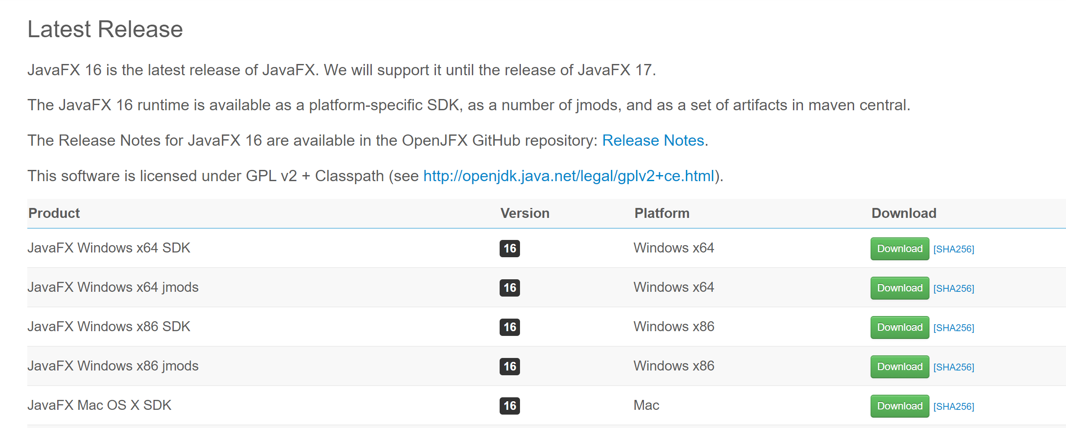

Once you installed include that in Intellij

Go to File>ProjectStructure>Libraries

● Here add you javafx lib file path like this

</Users/farhat/Downloads/javafx-sdk-16/lib>

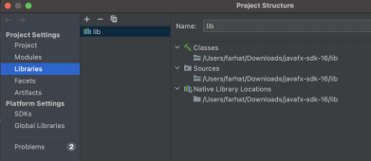

Now go to Run>Edit configuration

And add below one

--module-path /Users/farhat/Downloads/javafx-sdk-16/lib --add-modules javafx.controls,javafx.fxml,,javafx.media

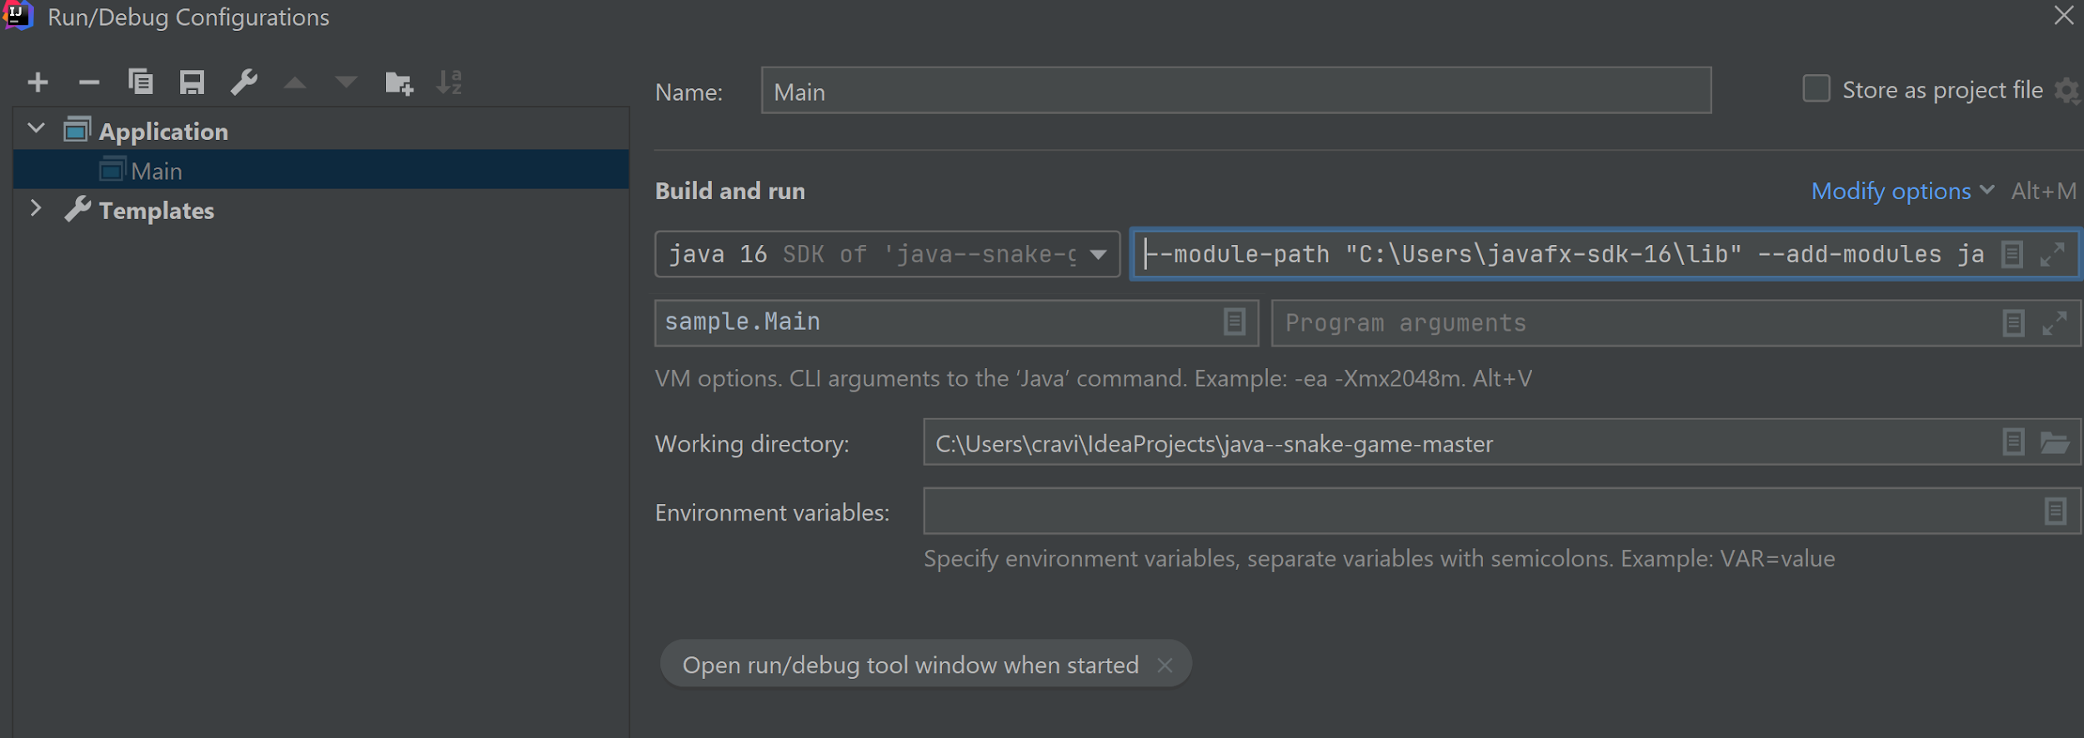

Add

--module-path "C:\Users\javafx-sdk-16\lib" --add-modules javafx.controls,javafx.fxml,,javafx.media